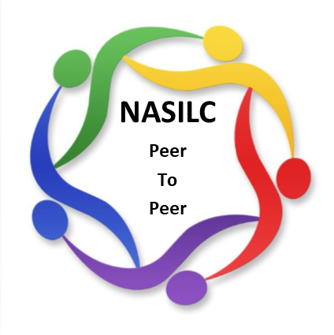

*Mission: To provide resources to SILCs across the nation and promote collaboration with their partners to advance IL values and philosophy.*

**NASILC Board of Directors Meeting Agenda**

**April 28, 2025 –**

**10:00 AM Pacific, 11:00 AM Mountain, 12:00 PM Central, 1:00 PM Eastern**

Register in advance for this meeting:

<https://zoom.us/meeting/register/1Ienfb7QT_u1W5kaONRvuA>

Call to Order Brooke Wilson

Board member Roll Call Gloria Garton

Member Comment (3 minutes) Brooke Wilson

Approval of January 27, 2025 Meeting Minutes Gloria Garton

Treasurer Transition Report Jeremy Morris

2025 SILC Congress Carrie England

Committee Reports

Bylaws & Policies & Procedures Mel Leviton

Advocacy & National Strategy Gloria Garton

Membership & Nominations Mellie Adu

Conference Planning – 2026 SILC Congress Jami Davis

Region Representatives Carrie England

Advocacy & Outreach – Resource Directory Gloria Garton

Partner Updates Brooke Wilson

T/TA contract

Collaborations-Contracts

General Updates All

Adjourn

\***Next meeting scheduled for July 28, 2025**